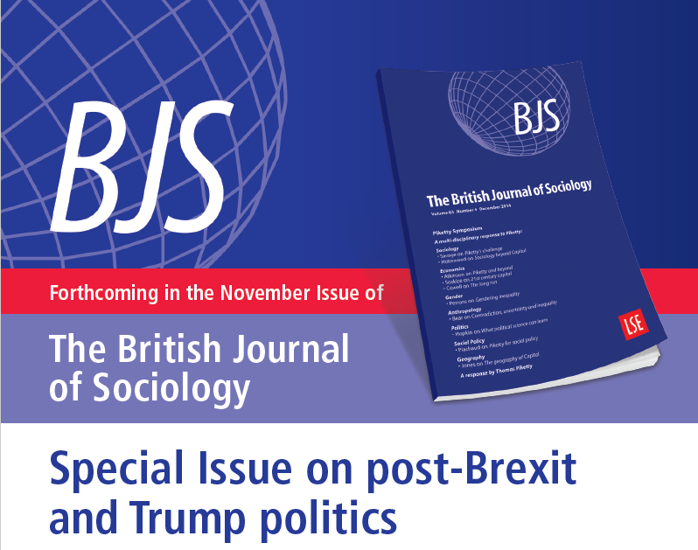

Edited by **Nigel Dodd, Michèle Lamont and Mike Savage**

*The British Journal of Sociology* presents a special issue in November 2017 containing reflections on the US election and related political developments in Europe, such as the ‘Brexit’ referendum in the UK.

The aim of the collection is to ask how can we understand the election of Donald Trump as President of the United States, and what sense sociologists in particular can make of the political events that are now shaping political and social life in the US, the UK, and elsewhere. We will examine the dimensions of sociology to which the election result calls attention – for example, populism, nationalism, racism. inequality, anti-elite politics, migration, finance, and expertise – as well as considering the broader global patterns in which Donald Trump’s election appears to fit. The papers included in this exciting and significant special issue will reflect on how we – as citizens as well as scholars – should respond to these events.

Contributors include: Michèle Lamont, Lisa McKenzie, Mike Savage, Patrick Le Galès, Desmond King, Noam Gidron, Peter A. Hall, Gurminder K. Bhambra, Bart Bonikowski, Bo Yun Park, Elena Ayala- Hurtado, Michael McQuarrie, Paul Pierson, Magne Flemmen, Leslie McCall and Ann Shola Orloff





**Special Issue: ‘The Trump/Brexit Moment’**

**Nigel Dodd, Michèle Lamont and Mike Savage, *Editorial: The Trump/Brexit Moment***

The articles in this issue were all commissioned in the immediate aftermath of the UK’s Brexit referendum result in June 2016 and the election of Donald Trump as President of the United States in November 2016 to present a rapid sociological response to the challenges and questions posed by these tumultuous events. Ostensibly these are two very different kinds of political events. The Brexit referendum in the UK was an unprecedented popular vote on Britain’s membership of the European Union, whereas Trump was elected as a Republican candidate during the usual cycle of presidential elections. Notwithstanding the prominence of politicians such as Nigel Farage or Boris Johnson, Brexit was not focused around specific individual leaders, whereas the figure of Trump himself looms indelibly large in the American case. Brexit will be bound to have huge long-term constitutional implications for the UK, whereas Trump’s victory might have less fundamental consequences.

**Desmond King and Patrick Le Galès, *The three constituencies of the state: why the state has lost unifying energy***

We address resurgent populism by examining structural processes of state transformation in the UK, the US and France. Scholars stress the ‘unifying energy of the state’, a set of institutions and policies capable of limiting inequalities and defending legal regimes. One characteristic of modern Western statehood were packages of policies designed to integrate social groups and territories in part by ensuring common standards of provision and social citizenship across the nation state. This echoes James Scott’s critical analysis of the modernist project of the state (1998). This ‘unifying energy’ had different origins including nationalist movements, combatting external influence or powers, war, and preparing citizens for the rigours of industrialization. Overcoming class differences and territorial differences (including cultural, social and economic differences) was a major source of mobilization to feed this ‘unifying energy of the state’ in France, Italy or Spain for instance. Political and cultural identities are related in significant part to respective nation states. We argue that this ‘unifying energy’ was an essential component of statehood in Europe and in the US. It is now largely lost. We explain why and the significance of its displacement.

**Leslie McCall and Ann Shola Orloff, The multidimensional politics of inequality: taking stock of identity politics in the U.S. Presidential election of 2016**

Many Democrats hoped that a particular kind of identity politics – women’s – would help Hillary Clinton win the White House. In the aftermath of the election, some commentators bemoaned the fact that a majority of white women had voted for Trump, and called it a kind of betrayal, underlining their expectation that women would naturally, on the basis of their gender identity, support a woman with women-friendly politics. Indeed, this kind of thinking about identity politics has been widespread with reference to a number of demographic groups. Meanwhile, identity politics is lamented from the right and left by those who favour a greater emphasis on class-based inequalities, or a greater national identity, some of whom blame identity politics for spawning or justifying a backlash of rightleaning populism in the US. We argue for a turn to a more robust definition of identity as multidimensional and politically mediated for understanding political alignments over the past several decades. The multidimensionality of inequality – intersectionality or complex inequality – is widely accepted in the study of gender and race across the social science disciplines but has yet to be as successfully integrated into studies of electoral politics. Thinking about women’s positioning in systems of complex inequality, and how the political parties have or have not articulated the concerns of different groups of women, helps us to understand the 2016 election, as well as past and potentially future political developments.

**Noam Gidron and Peter A. Hall, *The politics of social status: economic and cultural roots of the populist right***

This paper explores the factors that have recently increased support for candidates and causes of the populist right across the developed democracies, especially among a core group of working-class men. In the context of debates about whether the key causal factors are economic or cultural, we contend that an effective analysis must rest on understanding how economic and cultural developments interact to generate support for populism. We suggest that one way to do so is to see status anxiety as a proximate factor inducing support for populism, and economic and cultural developments as factors that combine to precipitate such anxiety. Using cross-national survey data from 20 developed democracies, we assess the viability of this approach. We show that lower levels of subjective social status are associated with support for right populist parties, identify a set of economic and cultural developments likely to have depressed the social status of men without a college education, and show that the relative social status of those men has declined since 1987 in many of the developed democracies. We conclude that status effects provide one pathway through which economic and cultural developments may combine to increase support for the populist right.





**Lawrence D. Bobo, *Racism in Trump’s America: reflections on culture, sociology, and the 2016 US presidential election***

Despite much positive change in the post civil rights era, U.S. notions of racism and white supremacy remain powerful elements of American culture. The adaptability and enduring power of these forces can be seen in the emergence of a new historical epoch best describe as the era of Laissez Faire Racism. Prevalent attitudes among white Americans, certain theoretical arguments and hypotheses in American sociology, as well the election of Donald Trump rest upon the on-going operation of racism. In particular, I attribute Trump’s electoral success to three critical dilemmas of race that defined contours of the 2016 presidential election: (1) worsening economic inequality in the presence of rapidly changing ethnoracial demography; (2) intensified political partisanship in the presence of wellinstitutionalized racially coded campaign strategies and rhetoric; and (3) the failure of the Clinton campaign to simultaneously champion the interests of working and middle class families and galvanize the previously powerful multiracial Obama coalition. I speculate on how to forge more effective multiracial coalitions in the future.

**Paul Pierson, *American hybrid: Donald Trump and the strange merger of populism and plutocracy***

Any effort to situate Trump’s ascendance in the broader currents of crossnational developments, or in the longer course of American political development, must begin by recognizing it as a curious hybrid of populism and plutocracy. Although American right-wing populism has real social roots, it has long been nurtured by powerful elites seeking to undercut support for modern structures of economic regulation and the welfare state. American political institutions offered a distinctive opportunity for a populist figure to draw on this fury to first capture the nomination of the GOP, and from that position to ascend to the White House. Yet the administration’s substantive agenda constitutes a fullthroated endorsement of the GOP economic elite’s long-standing demands for cuts in social spending, tax reductions for the wealthy, and the gutting of consumer, worker and environmental protections. The chasm between Trump’s rhetoric and his actions justifies a more skeptical assessment of the breadth and depth of American populism, one that acknowledges how its contours are shaped by the nation’s unusual political institutions, its intensifying political polarization and the out-sized influence of the wealthy.

**Michael McQuarrie, *The revolt of the Rust Belt: place and politics in the age of anger***

This paper argues that the election of Donald Trump is the product of a confluence of historical factors rather than the distinctive appeal of the victor himself. By paying particular attention to the geography of unusual voting behaviour the analytical question comes into view: why did so much uncharacteristic voting occur in the Rust Belt states of the upper Midwest? It is impossible to answer this question adequately using conventional categorical attributes. The usual hypotheses of ‘economic anxiety’ and white revanchism are unable to account for sudden shifts in the voting behaviour of both white and black voters in post-industrial territories. Instead, it is necessary to turn to the history of the region and the institutional apparatus that connected voters there to the federal government and the Democratic Party. From this perspective we can see that the active dismantling of the Fordist social order set the region on a divergent path from the rest of the country. But this path had no political outlet due to the reorientation of the Democratic Party around a new class and geographic base. Due to this, the party pursued policies that would magnify the region’s difficulties rather than alleviate its circumstances. Moreover, the elaborate institutional ties that connected the region’s voters to the Democratic Party and the federal government meant that the political implications of regional decline would be muted. However, as these institutions frayed, Rust Belt voters were made available to candidates that challenged the policy consensus that had done so much damage to the region. The election was decided by a Rust Belt revolt that unified black and white working-class voters against Hillary Clinton and the Democratic Party.

**Michèle Lamont, Park, Bo Yun Park and Elena Ayala-Hurtad, *Trump’s electoral speeches and the white working class***

This paper contributes to the study of social change by considering boundary work as a dimension of cultural change. Drawing on the computer-assisted qualitative analysis of 73 formal speeches made by Donald Trump during the 2016 electoral campaign, we argue that his political rhetoric, which led to his presidential victory, addressed the white working class’s concern with their declining position in the national pecking order. He addressed this group’s concern by raising their moral status, that is, by (1) emphatically describing them as hard-working Americans who are victims of globalization; (2) voicing their concerns about ‘people above’ (professionals, the rich, and politicians); (3) drawing strong moral boundaries toward undocumented immigrants, refugees, and Muslims; (4) presenting African Americans and (legal) Hispanic Americans as workers who also deserve jobs; (5) stressing the role of working-class men as protectors of women and LGBTQ people. This particular case study of the role of boundary work in political rhetoric provides a novel, distinctively sociological approach for capturing dynamics of social change.





**Bart Bonikowski, *Ethno-nationalist populism and the mobilization of collective resentment***

Scholarly and journalistic accounts of the recent successes of radical-right politics in Europe and the United States, including the Brexit referendum and the Trump campaign, tend to conflate three phenomena: populism, ethno-nationalism and authoritarianism. While all three are important elements of the radical right, they are neither coterminous nor limited to the right. The resulting lack of analytical clarity has hindered accounts of the causes and consequences of ethno-nationalist populism. To address this problem, I bring together existing research on nationalism, populism and authoritarianism in contemporary democracies to precisely define these concepts and examine temporal patterns in their supply and demand, that is, politicians’ discursive strategies and the corresponding public attitudes. Based on the available research, I conclude that both the supply and demand sides of radical politics have been relatively stable over time, which suggests that in order to understand public support for radical politics, scholars should instead focus on the increased resonance between pre-existing attitudes and discursive frames. Drawing on recent research in cultural sociology, I argue that resonance is not only a function of the congruence between a frame and the beliefs of its audience, but also of shifting context. In the case of radical-right politics, a variety of social changes have engendered a sense of collective status threat among national ethnocultural majorities. Political and media discourse has channelled such threats into resentments toward elites, immigrants, and ethnic, racial and religious minorities, thereby activating previously latent attitudes and lending legitimacy to radical political campaigns that promise to return power and status to their aggrieved supporters. Not only does this form of politics threaten democratic institutions and inter-group relations, but it also has the potential to alter the contours of mainstream public discourse, thereby creating the conditions of possibility for future successes of populist, nationalist, and authoritarian politics.

**Gurminder K. Bhambra, *Brexit, Trump, and ‘methodological whiteness’: on the misrecognition of race and class***

The rhetoric of both the Brexit and Trump campaigns was grounded in conceptions of the past as the basis for political claims in the present. Both established the past as constituted by nations that were represented as ‘white’ into which racialized others had insinuated themselves and gained disproportionate advantage. Hence, the resonant claim that was broadcast primarily to white audiences in each place ‘to take our country back’. The politics of both campaigns was also echoed in those social scientific analyses that sought to focus on the ‘legitimate’ claims of the ‘left behind’ or those who had come to see themselves as ‘strangers in their own land’. The skewing of white majority political action as the action of a more narrowly defined white working class served to legitimize analyses that might otherwise have been regarded as racist. In effect, I argue that a pervasive ‘methodological whiteness’ has distorted social scientific accounts of both Brexit and Trump’s election victory and that this needs to be taken account of in our discussion of both phenomena.

**Mike Savage and Magne Flemmen, *The politics of nationalism and white racism in the UK***

This paper considers the contemporary significance of white racism and its association with nationalist sentiment amongst a cohort late middle aged white Britons, using survey responses and qualitative interviews from the 1958 National Child Development Study. We have shown that although overt racism is very limited, a substantial minority of white Britons display ambivalent feelings which have the potential to be mobilised in racist directions. We argue against the view that disadvantaged white working class respondents are especially xenophobic, and show that racist views are not strongly associated with social position. In exploring the clustering of different nationalist and racist sentiments amongst economic and cultural elites, and comparing these with ‘disenfranchised’ respondents with little economic and cultural capital, we show that it is actually the elite who are most likely to articulate ‘imperial racism’. By contrast, the ‘disenfranchised’ articulate a kind of anti-establishment nationalism which is not strongly racist. We also show that the elite are strongly internally divided, with a substantial number of the cultural elite being strongly anti-racist and committed to multi-culturalism, so generating strong internal factionalism between elite positions. Our paper therefore underscores how intensifying inequalities have facilitated the volatility and variability of nationalist and racist sentiment.

**Lisa McKenzie on *The class politics of prejudice: Brexit and the land of no-hope and glory***

The debates relating to social class and whether it is still a useful concept in describing a lived reality of the British population has never been far away from media, political and academic dispute. Thatcher’s Britain throughout the 1980s attempted to dilute class meaning with what was called ‘a home owning democracy’ and thus end class collective politics through easily available credit for the working class while simultaneously attacking trade union organization, recruitment and political action. During the late 1990s and into the noughties a ‘New Labour’ administration attempted to exacerbate the end of class politics through an agenda of a ‘cultural distinction’ to class identity. Class struggle, class politics and class identity is embedded deep within the cultural norms practices, and history of British democracy. Consequently it is difficult if not impossible to prise class inequality in the UK away from and out of national, local and personal politics (Savage et al. 2015: 393–8). This paper focuses upon the sense that class politics, and cultural class distinction, within the UK had the biggest influence in determining a working-class ‘Leave Vote’ in the 2016 referendum within the UK. This paper explores accounts and narratives from working-class ‘leave’ voters though an ethnographic study of the political and social viewpoints of working-class communities of East London, and of ex-mining towns of Nottinghamshire. Framing into fuller context the anger and apathy of being ‘left out’, arguing that being ‘left out’ has been part of working-class political narratives for over 30 years. Going beyond frustration and apathy, a significant part of the narrative of working people was of ‘not existing’, suggesting certain important linkages with ongoing debates about new ways of conceptualizing class differences and class structures.

